**St Matthew’s Anglican Parish Cheltenham**

**7th Sunday after Pentecost /OS 17**

**Sunday 27th July 2025**

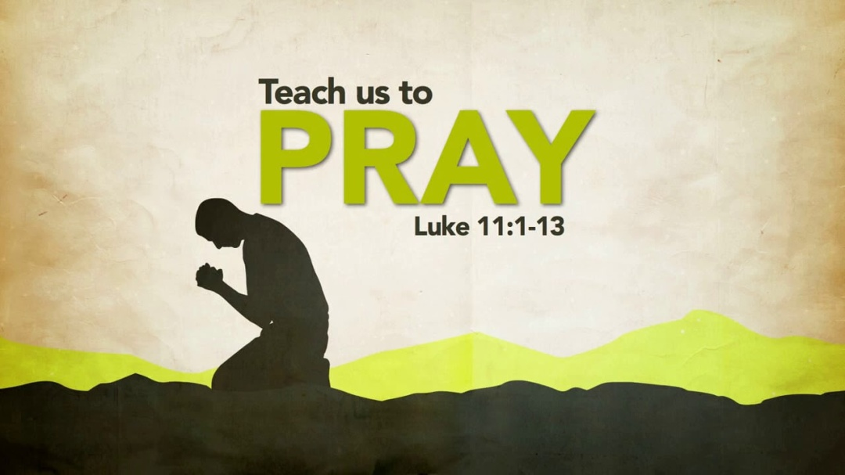

**Vicar: Fr Gerald Loos**

**Organist: Mr Keith Fullard**

*This church stands on the land of the Boon Wurrung people.   
We respectfully acknowledge their elders,*

*past and present, and we pray*

*for the ongoing work of reconciliation.*

OPENING HYMN: **What a friend we have in Jesus**

##### TIS 590

**What a friend we have in Jesus**

**all our sins and griefs to bear,**

**what a privilege to carry**

**everything to God in prayer:**

**O what peace we often forfeit,**

**O what needless pain we bear,**

**all because we do not carry**

**everything to God in prayer.**

**Have we trials and temptations,**

**is there trouble anywhere?**

**We should never be discouraged:**

**take it to the Lord in prayer.**

**Can we find a friend so faithful**

**who will all our sorrows share?**

**Jesus knows our every weakness:**

**take it to the Lord in prayer.**

**Are we weak and heavy-laden,**

**cumbered with a load of care?**

**Jesus is our only refuge:**

**take it to the Lord in prayer.**

**Do your friends despise, forsake you?**

**Take it to the Lord in prayer;**

**in his arms he'll take and shield you,**

**you will find a solace there.**

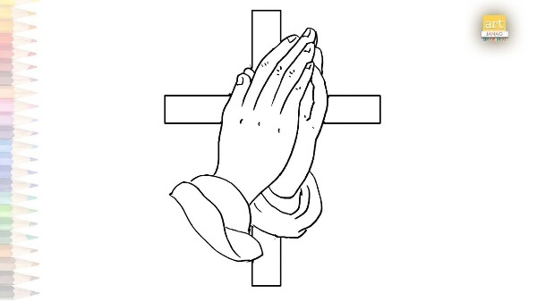

GATHERING IN GOD’S NAME

In the name of the Father and the Son and the Holy Spirit. **Amen** The Lord be with you.

**And also with you.**

Cantor – God is in his holy habitation. God gives the desolate a home to dwell in, he gives power and strength to his people.

Let us pray.

**Almighty God, to whom all hearts are open, all desires known, and from whom no secrets are hidden: cleanse the thoughts of our hearts by the inspiration of your Holy Spirit,**

**that we may perfectly love you, and worthily magnify your holy name, through Christ our Lord. Amen.**

*The Invitation to Confession*

*Silence may be kept.*

**Merciful God,  
our maker and our judge,  
we have sinned against you  
in thought, word, and deed,**

**and in what we have failed to do:  
we have not loved you with our whole heart;  
we have not loved our neighbours**

**as ourselves;  
we repent, and are sorry for all our sins.  
Father, forgive us.  
Strengthen us to love and obey you  
in newness of life;  
through Jesus Christ our Lord. Amen.**

Almighty God, who has promised forgiveness to all who turn to him in faith: pardon you and set you free from all your sins, strengthen you in all goodness and keep you in eternal life, through Jesus Christ our Lord. **Amen.**

**♫ Lord, have mercy (x3)**

**Christ, have mercy (x3)**

**Lord, have mercy (x3)**

*The Gloria*

♫ **Glory to God in the highest,**

**and peace to God’s people on earth.**

**Lord God, heavenly King,**

**almighty God and Father,**

**we worship you, we give you thanks,**

**we praise you for your glory.**

**Lord Jesus Christ, only Son of the Father,**

**Lord God, Lamb of God,**

**you take away the sin of the world:**

**have mercy on us;**

**you are seated at the right hand of the Father: receive our prayer.**

**For you alone are the Holy One,**

**you alone are the Lord,**

**you alone are the Most High Jesus Christ,**

**with the Holy Spirit,**

**in the glory of God the Father. Amen.**

**THE COLLECT**

Let us pray,

O God our Father, with the prayer your Son taught us always on our lips, we ask, we seek, we knock at your door: help us so to seek that we may truly find, so to ask that we may joyfully receive, and so to knock that the door of mercy may be opened for us; through Jesus Christ our Lord. **Amen.**

**THE MINISTRY OF THE WORD**

**FIRST READING**

A reading from the book of Hosea

(Hosea 1:2-10 – found on page 730 in the pew bibles)

For the word of the Lord.

**Thanks be to God.**

**RESPONSORIAL PSALM:** 138

**~~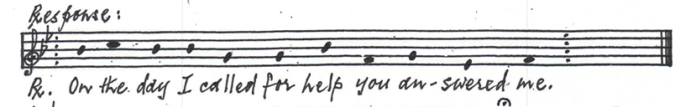~~**

**~~R~~: On the day I called for help you answered me.**

I will give you thanks, O Lord, with my whole heart:

even before the gods will I sing your praises.

I will bow down toward your holy temple

and give thanks to your name:

because of your faithfulness and your loving-kindness,

for you have made your name and your word

supreme over all things.

 At a time when I called to you, you gave me answer:

and put new strength within my soul. **~~R~~:**

All the kings of the earth shall praise you, O Lord:

for they have heard the words of your mouth;

And they shall sing of the ways of the Lord:

that the glory of the Lord is great.

For though the Lord is exalted, he looks upon the lowly:

and he comprehends the proud from afar. **~~R~~:**

Though I walk in the midst of danger,

yet will you preserve my life:

you will stretch out your hand against the fury of my

enemies, and your right hand shall save me.

The Lord will complete his purpose for me:

your loving-kindness, O Lord, endures for ever;

do not forsake the work of your own hands. **~~R~~:**

**SECOND READING**

A reading from Paul’s letter to the Colossians

(Colossians 2.6-15 – found on page 957 in the pew bibles)

For the word of the Lord.

**Thanks be to God.**

**THE GOSPEL READING** *Please stand for the Gospel*

♫ Alleluia, Alleluia, Alleluia, Alleluia.

**Alleluia, Alleluia, Alleluia, Alleluia.**

♫ Cantor – Ask and it will be given you, seek and you will find, knock and the door will be opened for you.

**Alleluia, Alleluia, Alleluia, Alleluia.**

The Lord be with you.

**And also with you.**

The Gospel of our Lord Jesus Christ according toLuke

**Glory to you Lord Jesus Christ.**

(Luke 11:1-13 – found on page 845 in the pew bibles)

For the Gospel of the Lord.

**Praise to you Lord Jesus Christ.**

**The Sermon**

*Silence may be kept*.

**The Nicene Creed**

Let us together affirm the faith of the Church

**We believe in one God,**

**the Father, the almighty,**

**maker of heaven and earth,**

**of all that is, seen and unseen.**

**We believe in one Lord, Jesus Christ,**

**the only Son of God,**

**eternally begotten of the Father,**

**God from God, Light from Light,**

**true God from true God,**

**begotten, not made,**

**of one being with the Father;**

**through him all things were made.**

**For us and for our salvation**

**he came down from heaven,**

**was incarnate of the Holy Spirit and the virgin Mary and became truly human.**

**For our sake he was crucified under Pontius Pilate; he suffered death and was buried.**

**On the third day he rose again**

**in accordance with the Scriptures;**

**he ascended into heaven**

**and is seated at the right hand of the Father.**

**He will come again in glory to judge**

**the living and the dead**

**and his kingdom will have no end.**

**We believe in the Holy Spirit,**

**the Lord, the giver of life,**

**who proceeds from the Father and the Son,**

**who with the Father and the Son**

**is worshipped and glorified,**

**who has spoken through the prophets.**

**We believe in one holy**

**catholic and apostolic Church.**

**We acknowledge one baptism for the**

**forgiveness of sins.**

**We look for the resurrection of the dead,**

**and the life of the world to come. Amen.**

THE PRAYERS OF THE PEOPLE

Loving and merciful God,

You are steadfast in your love for your people, and you answer us when we call on you: hear us now as we bring our prayers for your world and for your church.

We pray for your world.

For all your people whose lives are threatened by war, terrorism or disaster, by famine or disease;

for leaders of nations, those who govern and those who dispense justice.

Loving God, in your mercy, **hear our prayer.**

We pray for your church.

We pray for all who are fed at your table;

for pastors and teachers and all who provide spiritual nourishment to your people.

Loving God, in your mercy, **hear our prayer.**

We pray for those close and dear to us.

We pray for all who live in this suburb and those whose daily work enriches this community;

for members of this parish, for our families, our friends and for ourselves.

Loving God, in your mercy, **hear our prayer.**

We pray for those in need.

We pray for all who have no work, no home, no hope for the future; for the sad and the lonely, for the sick and all who care for them.

Loving God, in your mercy, **hear our prayer.**

Almighty God, you have promised to hear our prayers.

**Grant that what we have asked in faith we may by your grace receive, through Jesus Christ our Lord. Amen.**

THE GREETING OF PEACE

We are the body of Christ.

**His spirit is with us.**

The peace of the Lord be always with you.

**And also with you.**

HYMN: **Just as I am, without one plea TIS 584**

**Just as I am, without one plea**

**but that your blood was shed for me,**

**and that you would my Saviour be,**

**O Lamb of God, I come.**

**Just as I am, though tossed about**

**with many a conflict, many a doubt,**

**fightings and fears within, without,**

**O Lamb of God, I come.**

**Just as I am, poor, wretched, blind**

**sight, riches, healing of the mind,**

**yes, all I need, in you to find,**

**O Lamb of God, I come.**

**Just as I am, you will receive,**

**will welcome, pardon, cleanse, relieve;**

**because your promise I believe,**

**O Lamb of God, I come.**

**Just as I am — your love unknown**

**has broken every barrier down**

**now to be yours, and yours alone,**

**O Lamb of God, I come.**

**Just as I am, of that free love**

**the breadth, length, depth and height to prove,**

**here for a season, then above,**

**O Lamb of God, I come.**

Blessed are you, Lord, God of all creation.

Through your goodness we have these gifts to share.

Accept and use our offerings for your glory

and for the service of your kingdom.

**Blessed be God for ever.**

Pray, my sisters and brothers, that our sacrifice may be acceptable to God, the almighty Father.

**May the Lord accept the sacrifice at your hands for the praise and glory of his name, for our good, and the good of all his Church.**

Lord, let this offering to the glory of your name purify us and bring us closer to eternal life. We ask this through Christ our Lord. **Amen.**

THE GREAT THANKSGIVING

♫The Lord be with you.

**And also with you.**

Lift up your hearts**.**

**We lift them to the Lord.**

Let us give thanks to the Lord our God.

**It is right to give our thanks and praise.**

All glory and honour be yours always and everywhere,

mighty Creator, everliving God.

We give you thanks and praise for our Saviour Jesus Christ,

who by the power of your Spirit was born of Mary and lived as one of us.

By his death on the cross and rising to new life,

he offered the one true sacrifice for sin

and obtained an eternal deliverance for his people.

Therefore with angels and archangels,

and with all the company of heaven,

we proclaim your great and glorious name,

for ever praising you and saying:

**Holy, holy, holy Lord,**

**God of power and might,**

**Heaven and earth are full of your glory.**

**Hosanna in the highest.**

**Blessed is he who comes in the name**

**of the Lord.**

**Hosanna in the highest.**

Merciful God, we thank you

for these gifts of your creation,

this bread and wine,

and we pray that by your Word and Holy Spirit,

we who eat and drink them

may be partakers of Christ's body and blood.

On the night he was betrayed Jesus took bread;

and when he had given you thanks

he broke it, and gave it to his disciples, saying,

'Take, eat. This is my body given for you.

Do this in remembrance of me.'

After supper, he took the cup,

and again giving you thanks

he gave it to his disciples, saying,

'Drink from this, all of you.

  This is my blood of the new covenant

shed for you and for many

for the forgiveness of sins.

Do this, as often as you drink it,

in remembrance of me.

'

Let us proclaim the mystery of faith

**Christ has died.**

**Christ is risen.**

**Christ will come again.**

Therefore we do as our Saviour has commanded:

proclaiming his offering of himself

made once for all upon the cross,

his mighty resurrection and glorious ascension,

and looking for his coming again,

we celebrate, with this bread and this cup,

his one perfect and sufficient sacrifice for the sins of the whole world.

 Renew us by your Holy Spirit,

unite us in the body of your Son,

and bring us with all your people

into the joy of your eternal kingdom;

through Jesus Christ our Lord,

with whom, and in whom,

in the fellowship of the Holy Spirit,

we worship you, Father,

in songs of never-ending praise:

**Blessing and honour and glory and power**

**are yours for ever and ever. Amen.**



♫As our Saviour Christ has taught us, we are confident to pray,

THE BREAKING OF THE BREAD

AND THE COMMUNION

We break this bread to share in the body of Christ.

**We who are many are one body,**

**for we all share in the one bread.**

♫ **Jesus, Lamb of God, have mercy on us.**

**Jesus, bearer of our sins, have mercy on us.**

**Jesus, redeemer of the world,**

**grant us your peace.**

Behold the Lamb of God

who takes away the sins of the world.

Happy are those who are called to his supper.

**Lord, I am not worthy to receive you, but only say the word, and I shall be healed.**

*The sacrament is given with the following words*

The body and blood of Christ keep you in eternal life. **Amen.**

THE SENDING OUT OF GOD’S PEOPLE

♫ Cantor – Be imitators of God as beloved children: walk in love as Christ loved us and gave himself up for us.

Let us pray.

Father, in this eucharist we have shared the joy of salvation. May this food renew us in Christ, who came to call not the just but sinners to salvation in his kingdom where he is Lord for ever and ever

**Father, we offer ourselves to you**

**as a living sacrifice**

**through Jesus Christ our Lord.**

**Send us out in the power of your Spirit**

**to live and work to your praise and glory. Amen**

*Please remain seated for some announcements.*

THE BLESSING AND DISMISSAL

*If you are able, please stand for God’s blessing*

The peace of God, which passes all understanding, keep your hearts and minds in the knowledge and love of God,

and of his Son Jesus Christ our Lord; and the blessing of God almighty, the Father, the Son, and the Holy Spirit,

be among you and remain with you always. **Amen.**

Go in peace to love and serve the Lord.

**In the name of Christ. Amen.**

HYMN: **Seek ye first the kingdom of God TIS 745**

**Seek ye first the kingdom of God  
And His righteousness;  
And all these things shall be added unto you.  
Allelu, alleluia.**

***Alleluia, alleluia,  
 alleluia, alleluia, alleluia.*  
  
Man shall not live by bread alone,  
But by every word  
That proceeds out from the mouth of God.  
Allelu, alleluia.  
 *Alleluia, alleluia,  
 alleluia, alleluia, alleluia.*  
  
Ask, and it shall be given unto you;  
Seek, and ye shall find.  
Knock, and the door shall be opened unto you.  
Allelu, alleluia.  
 *Alleluia, alleluia,  
 alleluia, alleluia, alleluia.***

*All hymns and text used with permission from the Australian Prayer Book of Australia, New English Hymnal, Together in Song. CCLI Licence #5371063*



Morning tea in hall today

Parish council today @ 11:30am

**Feast / Special days**

17 August – Mary mother of the Lord

24 August – Daffodil day

21 September – St Matthew

5 October – St Francis of Assisi

**Soup Lunch in Winter months**

On the first Sunday August there will be a soup lunch in the parish hall.

We need volunteers to help with making soups All are invited to stay and enjoy a time of fellowship



**Bunnings Sausage Sizzle**

St Matthew’s will be having a sausage sizzle at Bunnings as a parish fund raiser on Sunday 7 September from 8am onwards. Please support

**Service Roster 3 August 2025 - 8th After Pentecost**

|  |  |
| --- | --- |
| **Volunteer roster:** | **Readings:** |
| Welcomer: Barbara  Chalice: Sandra  Reader: Deborah  Intercessor: Elizabeth | Hosea 11:1-11  Psalm 95  Colossians 1:1-14  Luke 12: 13-21 |

**Prayer Diary:**

|  |  |  |
| --- | --- | --- |
| Monday | 28th | Marie Murray-Arthur  Romain Ohlmus  Gillian Palliser |
| Tuesday | 29th | Helen Pederick  Sue Polites  Polites / Scully family – Deb, Patrick & Gabrielle |
| Wednesday | 30th | Rev Jill Renison  Beverley Roberts  Shaun Schoorman |
| Thursday | 31st | Cherrine Siebel  Cliff & Marilyn Simmons  Jean & George Stokes |
| Friday | 1st | Roma Swallow  Sharon Tapner, Derek & Mitchell Sereen  Peggy Triggs |
| Saturday | 2nd | CHN  St. Matthew’s Cheltenham |

**PASTORAL VISIT**

If you would like a pastoral visit, please speak to Fr Gerald to organize a date and time

If you have a name of someone in need of prayer or pastoral care, please contact Fr Gerald or the parish office. Out of respect for privacy, make sure you have that person’s permission.

****In todays gospel, the disciples ask Jesus to teach them how to pray. It’s a humble and beautiful request—an acknowledgment that prayer is not just instinctive but something that must be learned, practiced, and shaped by faith.

Jesus responds by giving them the Lord’s Prayer, a model that is both simple and profound. It starts with “Father”, reminding us that prayer begins with relationship. We approach God not as strangers or beggars, but as beloved children. The rest of the prayer balances two key dimensions of faith: reverence for God’s holiness (“hallowed be your name”) and trust in His provision (“give us each day our daily bread”), forgiveness, and guidance.

But Jesus doesn’t stop with the prayer itself. He follows it with a parable about a persistent friend knocking at midnight, asking for bread. The message is clear: God welcomes our persistence. Not because He is reluctant to help, but because persistence deepens our trust and reveals our dependence on Him. The key takeaway is not that we must wear God down with repetition, but that we can approach Him boldly and confidently, trusting in His love and generosity.

Jesus concludes with powerful encouragement: “Ask, and it will be given to you; seek, and you will find; knock, and the door will be opened.”

This is not a blank cheque for any desire, but a promise that God hears and answers prayer, often in ways that form us, stretch us, and bless us more deeply than we expect. Especially striking is verse 13: “How much more will your Father in heaven give the Holy Spirit to those who ask him!”

In other words, the greatest gift of prayer is not just getting what we want—but receiving more of God Himself. The Holy Spirit is the answer to our deepest needs and longings.



**Pastoral Care Initiative – Reaching Out to the Lost Sheep**

As part of our parish’s pastoral care ministry, we are seeking to reconnect with members of our community who may have drifted away from the Church or no longer attend regularly. Fr Gerald is planning to personally visit or contact those who have fallen away, to offer care, prayer, and a welcoming invitation back into the life of our parish.

If you know of anyone—family members, friends, or neighbours who has stopped attending church or feels disconnected, please pass their names and contact details confidentially to Fr Gerald.

Together, let us be the hands and heart of Christ, reaching out with love and compassion to all.

***“Rejoice with me; I have found my lost sheep.” – Luke 15:6***

**EVERYONE IS WELCOME AT ST MATTHEW’S**

**First Sunday of the Month**:

8:00am A quiet, said service of Holy Communion

**Every Sunday**:

9:30am A sung service of Holy Communion

with a Children’s Program

**Wednesdays** (not in January):

9:45am Prayer for Healing, Wholeness and Peace

10:00am A quiet, said service of Holy Communion

**Monday, Thursday and Friday mornings**:

9:00-9:30 am Morning Prayer via Zoom.

The link can be found in the Parish e-newsletter.

Meeting ID: 796 1738 1243

Passcode: 8hzrij

If you would like to donate to St Matthew’s, thank you!

Our bank details are:

St Matthew’s Anglican Church

BSB 06 3119 Acc. No. 1044 5437



Contact Details:

**Vicar – Fr Gerald Loos SSC**

Mobile 0409 149 486

Wednesday – Healing Mass and Home Communions

Thursday - Office Day in Parish Office

Friday – Pastoral Visits

Please note that Fr Gerald will be taking his regular day off on Monday. Should there be an emergency or if you require urgent pastoral care, he can be contacted on his mobile.

[vicar@stmatthewscheltenham.org.au](mailto:vicar@stmatthewscheltenham.org.au)

www.stmatthewscheltenham.org.au